Trần Văn Quyền
MSSV: 19574802010166
Lớp: 60K2 – CNTT

Câu 1:
import cv2
img = cv2.imread('D:\Tran Quyen\Document\Image\quyen.png')
gray = cv2.cvtColor(img, cv2.COLOR_BGR2GRAY)

sobelx = cv2.Sobel(gray, cv2.CV_64F, 1, 0, ksize=3)
sobely = cv2.Sobel(gray, cv2.CV_64F, 0, 1, ksize=3)
sobel = cv2.addWeighted(sobelx, 0.5, sobely, 0.5, 0)

cv2.imshow("Anh tach bien", sobel)
cv2.imwrite('tach_bien.jpg', sobel)
cv2.waitKey(0)
cv2.destroyAllWindows()

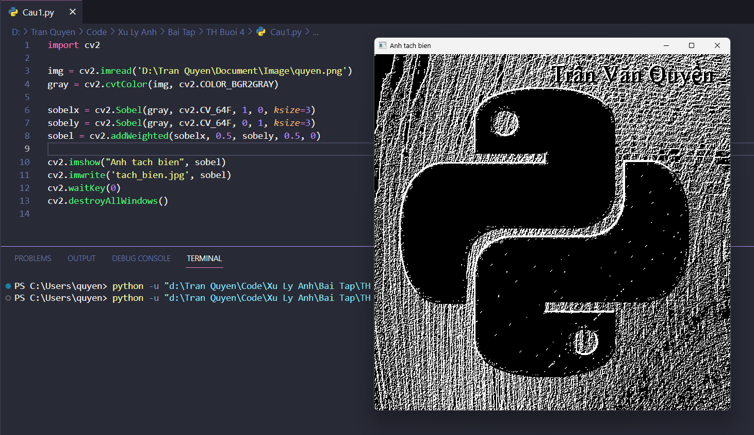
Câu 2:
import cv2
img = cv2.imread('D:\Tran Quyen\Document\Image\quyen.png')
gray = cv2.cvtColor(img, cv2.COLOR_BGR2GRAY)
laplacian = cv2.Laplacian(gray, cv2.CV_64F)
cv2.imshow("Anh tach bien", laplacian)
cv2.imwrite('D:\Tran Quyen\Document\Image\laplace_result.jpg', laplacian)
cv2.waitKey(0)
cv2.destroyAllWindows()
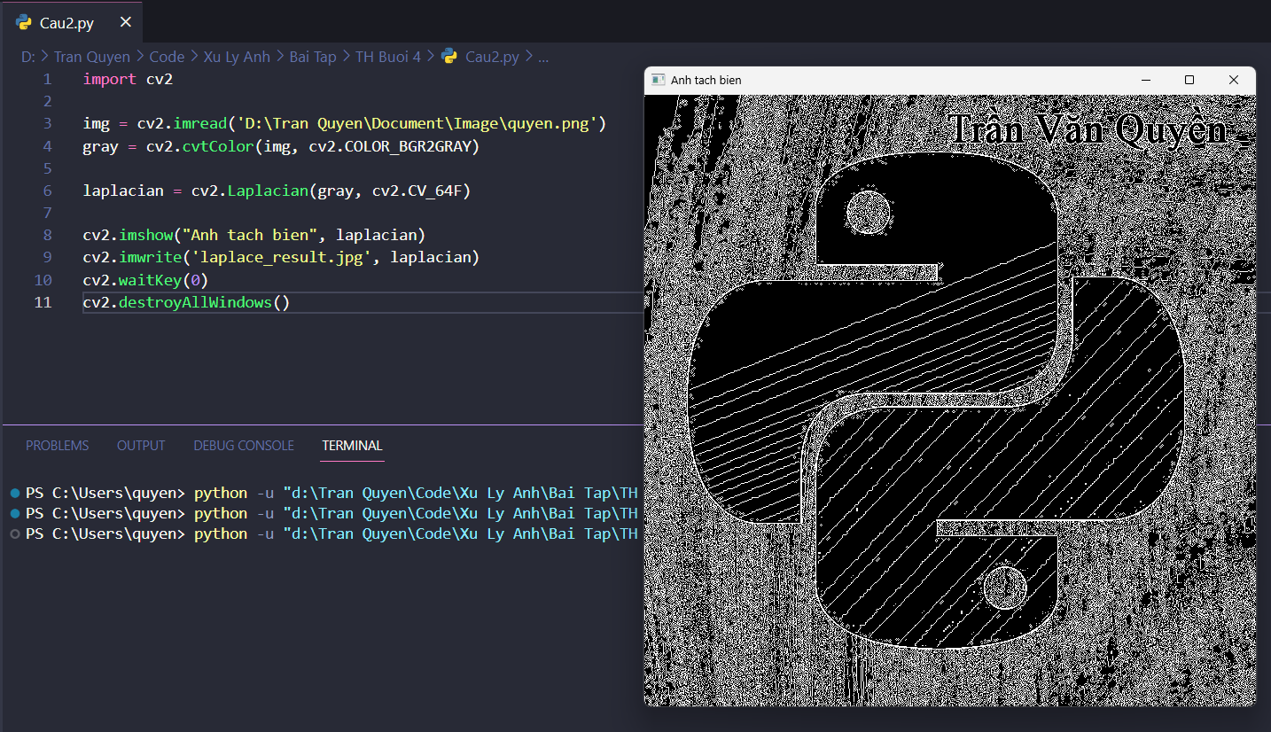
Câu 3:
import cv2
img = cv2.imread('D:\Tran Quyen\Document\Image\quyen.png')
gray = cv2.cvtColor(img, cv2.COLOR_BGR2GRAY)
canny = cv2.Canny(gray, 100, 200)
cv2.imshow("Canny", canny)
cv2.imwrite('D:\Tran Quyen\Document\Image\canny_result.jpg', canny)
cv2.waitKey(0)
cv2.destroyAllWindows()
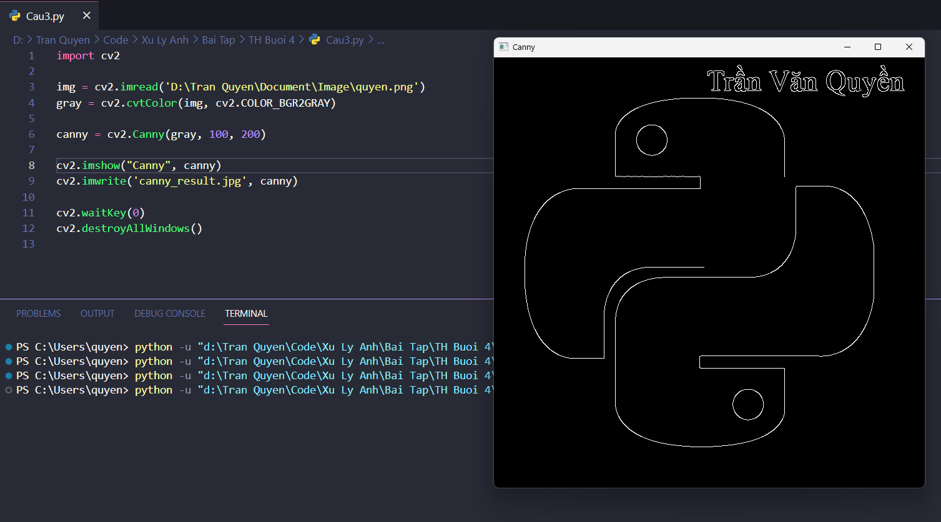
Câu 4:
import cv2
import matplotlib.pyplot as plt
img = cv2.imread('D:\Tran Quyen\Document\Image\quyen.png')
gray = cv2.cvtColor(img, cv2.COLOR_BGR2GRAY)
sobel = cv2.Sobel(gray, cv2.CV_64F, 1, 0, ksize=3)
laplacian = cv2.Laplacian(gray, cv2.CV_64F)
canny = cv2.Canny(gray, 100, 200)
fig, axs = plt.subplots(2, 2, figsize=(10, 10))
axs[0, 0].imshow(cv2.cvtColor(img, cv2.COLOR_BGR2RGB))
axs[0, 0].set_title('Original Image')
axs[0, 1].imshow(sobel, cmap='gray')
axs[0, 1].set_title('Sobel Edge Detection')
axs[1, 0].imshow(laplacian, cmap='gray')
axs[1, 0].set_title('Laplacian Edge Detection')
axs[1, 1].imshow(canny, cmap='gray')
axs[1, 1].set_title('Canny Edge Detection')
plt.show()
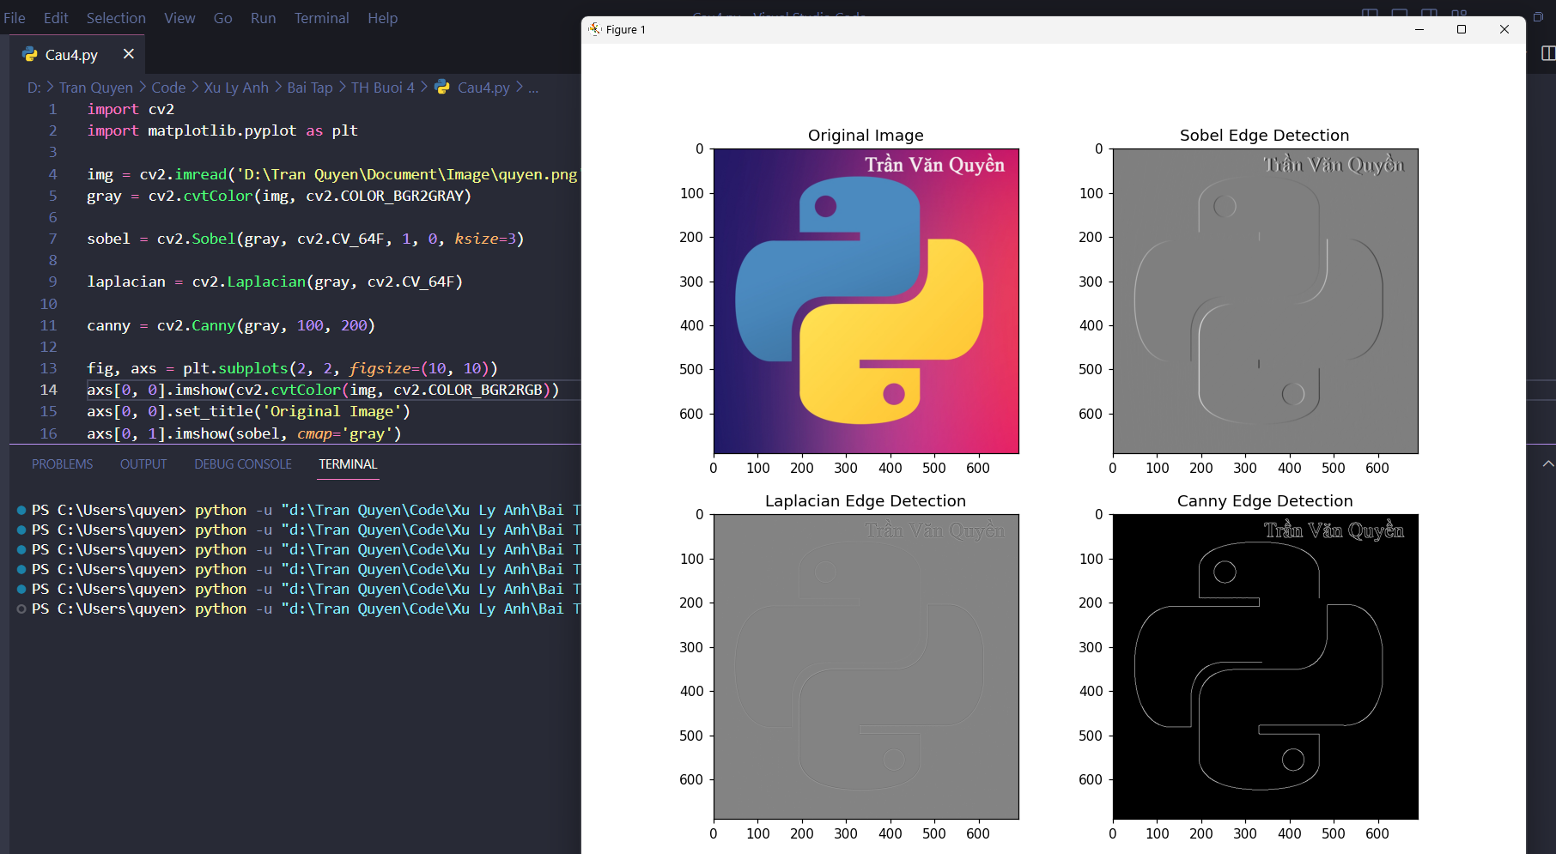
Câu 5:
import cv2
import numpy as np
def nothing(x):
pass
img = cv2.imread('D:\Tran Quyen\Document\Image\quyen.png')
gray = cv2.cvtColor(img, cv2.COLOR_BGR2GRAY)
cv2.namedWindow('image')
cv2.namedWindow('edges')
cv2.createTrackbar('lower', 'image', 0, 255, nothing)
cv2.createTrackbar('upper', 'image', 0, 255, nothing)
while True:
lower = cv2.getTrackbarPos('lower', 'image')
upper = cv2.getTrackbarPos('upper', 'image')
edges = cv2.Canny(gray, lower, upper*3)
cv2.imshow('image', img)
cv2.imshow('edges', edges)
k = cv2.waitKey(1) & 0xFF
if k == 27:
break

cv2.destroyAllWindows()
